GEOGRAPHY TIPS FOR STUDENTS

DOING DIAGRAMS IN L3 EXTERNALS

Geography is a spatial subject and so the ability to show information in different ways is important. It is often said that a picture shows a thousand words so if you can replace all those words with a diagram go for it! As a result geography assessments try to incorporate information in both writing and visual formats so you need to be competent at both! If you are not an artist do not worry. You are not being marked on your ability to draw well but on how you show the information.

WHAT IS A DIAGRAM?

The word diagram is often used in assessment, as this is a big umbrella term that includes any kind or visual or non- written information. There are 4 main types of visuals you can do:
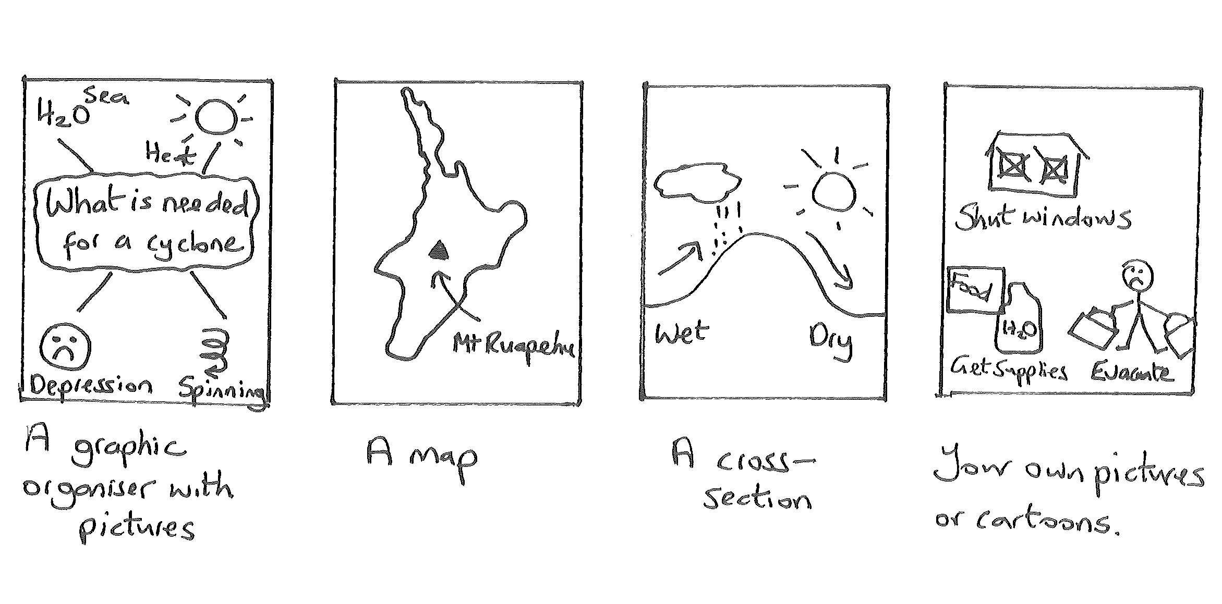Some questions may ask specifically for a map or cross section while other use the more general term of ‘a diagram’ that leaves it up to you. It is important that you read the question to determine where the visuals are to be included. These occur as either:

- A separate map, diagram or series of diagrams question – in this case it is important you follow the rules.
- To support an essay or written answer – spaces are not provided for these diagrams so simply draw a box on the lines provided. Such diagrams can be very small or rough and do not need to be as accurate such as including conventions. In these cases it is important to determine if diagrams MUST be included (means you can only get top marks if they are) or if they CAN be included (means you can get top marks without them). Try to use this type of diagram to add to information you have in the text rather than repeat it and refer to the diagrams in the text.

So what are the rules with a diagram? This sheet has been set out in easy to follow stages to show you how to answer a separate diagram question.

STAGE 1: READ THE QUESTION

Your diagram is there to answer a question. It is therefore important to read the question carefully and translate what you need to do in your own words. As an example take the question:

- Draw a map or diagram, to show TWO examples of spatial variation found in natural elements and / or natural features in your geographic environment.

This question is about how and why 2 characteristics (to do with natural elements or features) are like this here but are different in another location.

It also pays to see if this is an (a) question as if it is read the (b) before you start. Often the diagram will need you to identify something that you can write about in more detail in the (b) part. Since questions are marked holistically do not waste time repeating information in both parts. The diagram often fulfills the ‘describe’ part or sets the scene and the written part is the ‘explain’ part. Look to see if an instruction word is given in the question. Here it simply says ‘show’ so a description is adequate. If it said ‘explain’ or ‘analyse’ then you would need to include reasons. If there is no (b) part then this will have to include a lot more detail.

STAGE 2: PLAN YOUR ANSWER

Before you start drawing PLAN how you are going to do this. If we break this question down we need to:

- Decide what 2 spatial variations to show
- Decide on 2 places where each of these is very different
- Show how it is linked to a specific environment.

As an example let us imagine you are answering this using South Muriwai as the natural environment. If you were to jot down some choices of variations it may include:

- Variation in features (erosional features on the headland and depositional features on the beach)
- Variation in Geology (hard rock of the headland and soft rock on the beach)
- Variation in Vegetation (dense vegetation on headland and sparse vegetation on backshore of beach)
- Variation in erosion on different parts of the headland (wave erosion between tides and aerial erosion above)

When it comes to deciding which to use you need to consider which of them you know most about to explain in part (b) and to ensure a coverage of different processes so you are not repeating yourself in the explanation part.

STAGE 3: DRAW A BASE DIAGRAM

The next step is to produce a base diagram. You need to decide on the best way to show this information. In most cases at this level it will involve either a map or a cross section. This depends on what information you choose to show. Showing a difference between the headland and the beach area is only possible using a map. Showing a difference between the top and the bottom of the headland is only possible on a cross section.

Drawing maps is much easier if you are using a coastal environment as the coastline can give a definite boundary. Learn what this looks like and make it realistic. Remember there are no straight lines in the real world! For this question it is the natural environment you must concentrate on so include a range of these features. You can include some cultural features if they help identity the region but avoid going overboard with this. A busy map is hard to read and wastes time if the information is not essential.

For a cross section learn the approximate shape across different parts of your environment.

When drawing your base outline use a pencil first. It is difficult to get it correct the first time so this allows you to easily change it until you are satisfied. Once you are satisfied you can go over it in pen. A base outline for both a map and a cross section to answer the question would look like:
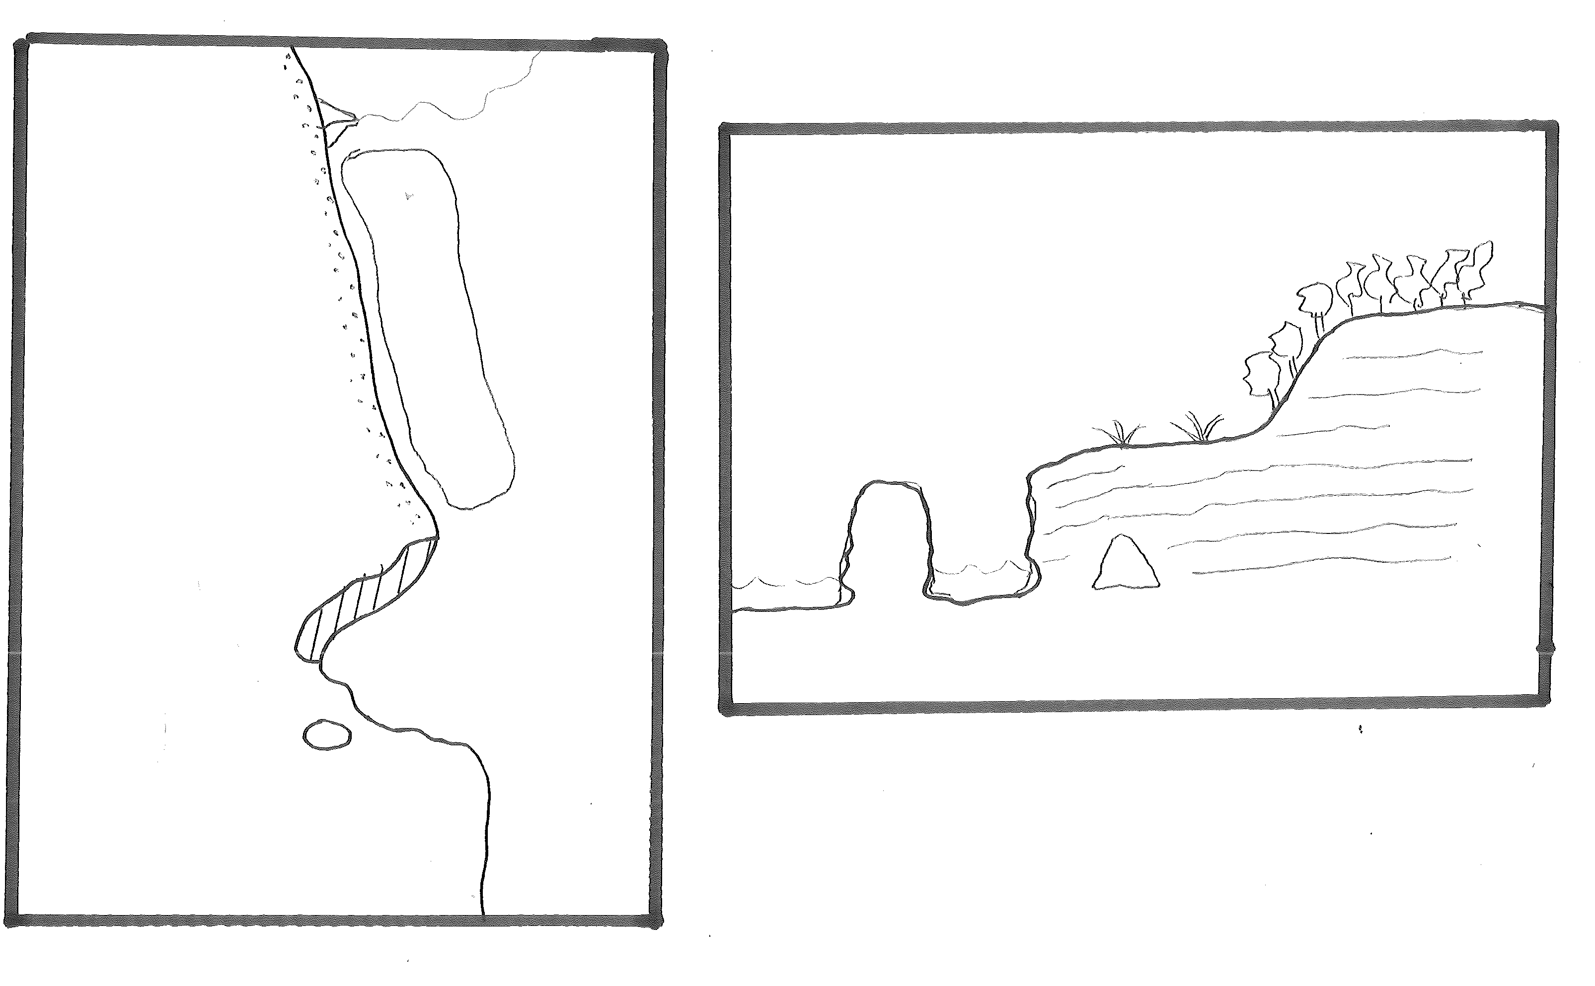
STAGE 4: ADD LABELS

Next it is important to link this diagram to an environment. You can do this by adding some names of places – easier to do in the case of a map but still possible on a cross section. Alternatively include this in the title or better still do both! Labels mean single words. Convention is to name places on the diagram and put the type of feature on a key.

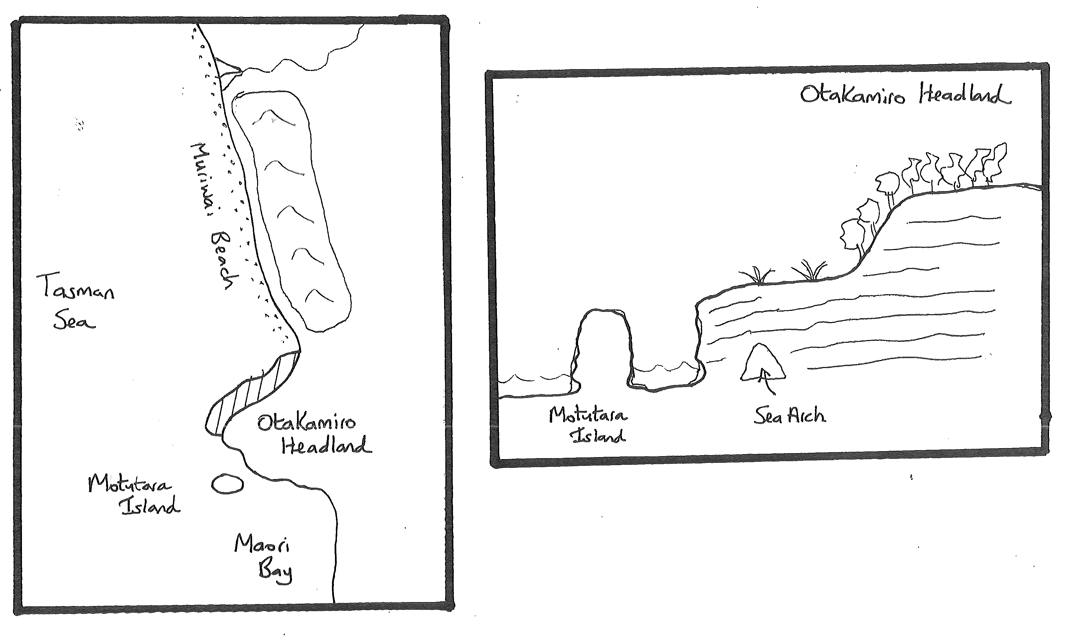
STAGE 5: ANNOTATE TO ANSWER THE QUESTION
The next stage is to adapt your base diagram to answer the set question. Our example requires you to show 2 variations. Use annotations to show these – this means put simple sentences or notes around them. Make it clear how you have answered the question or what your 2 variations are. These would look like:

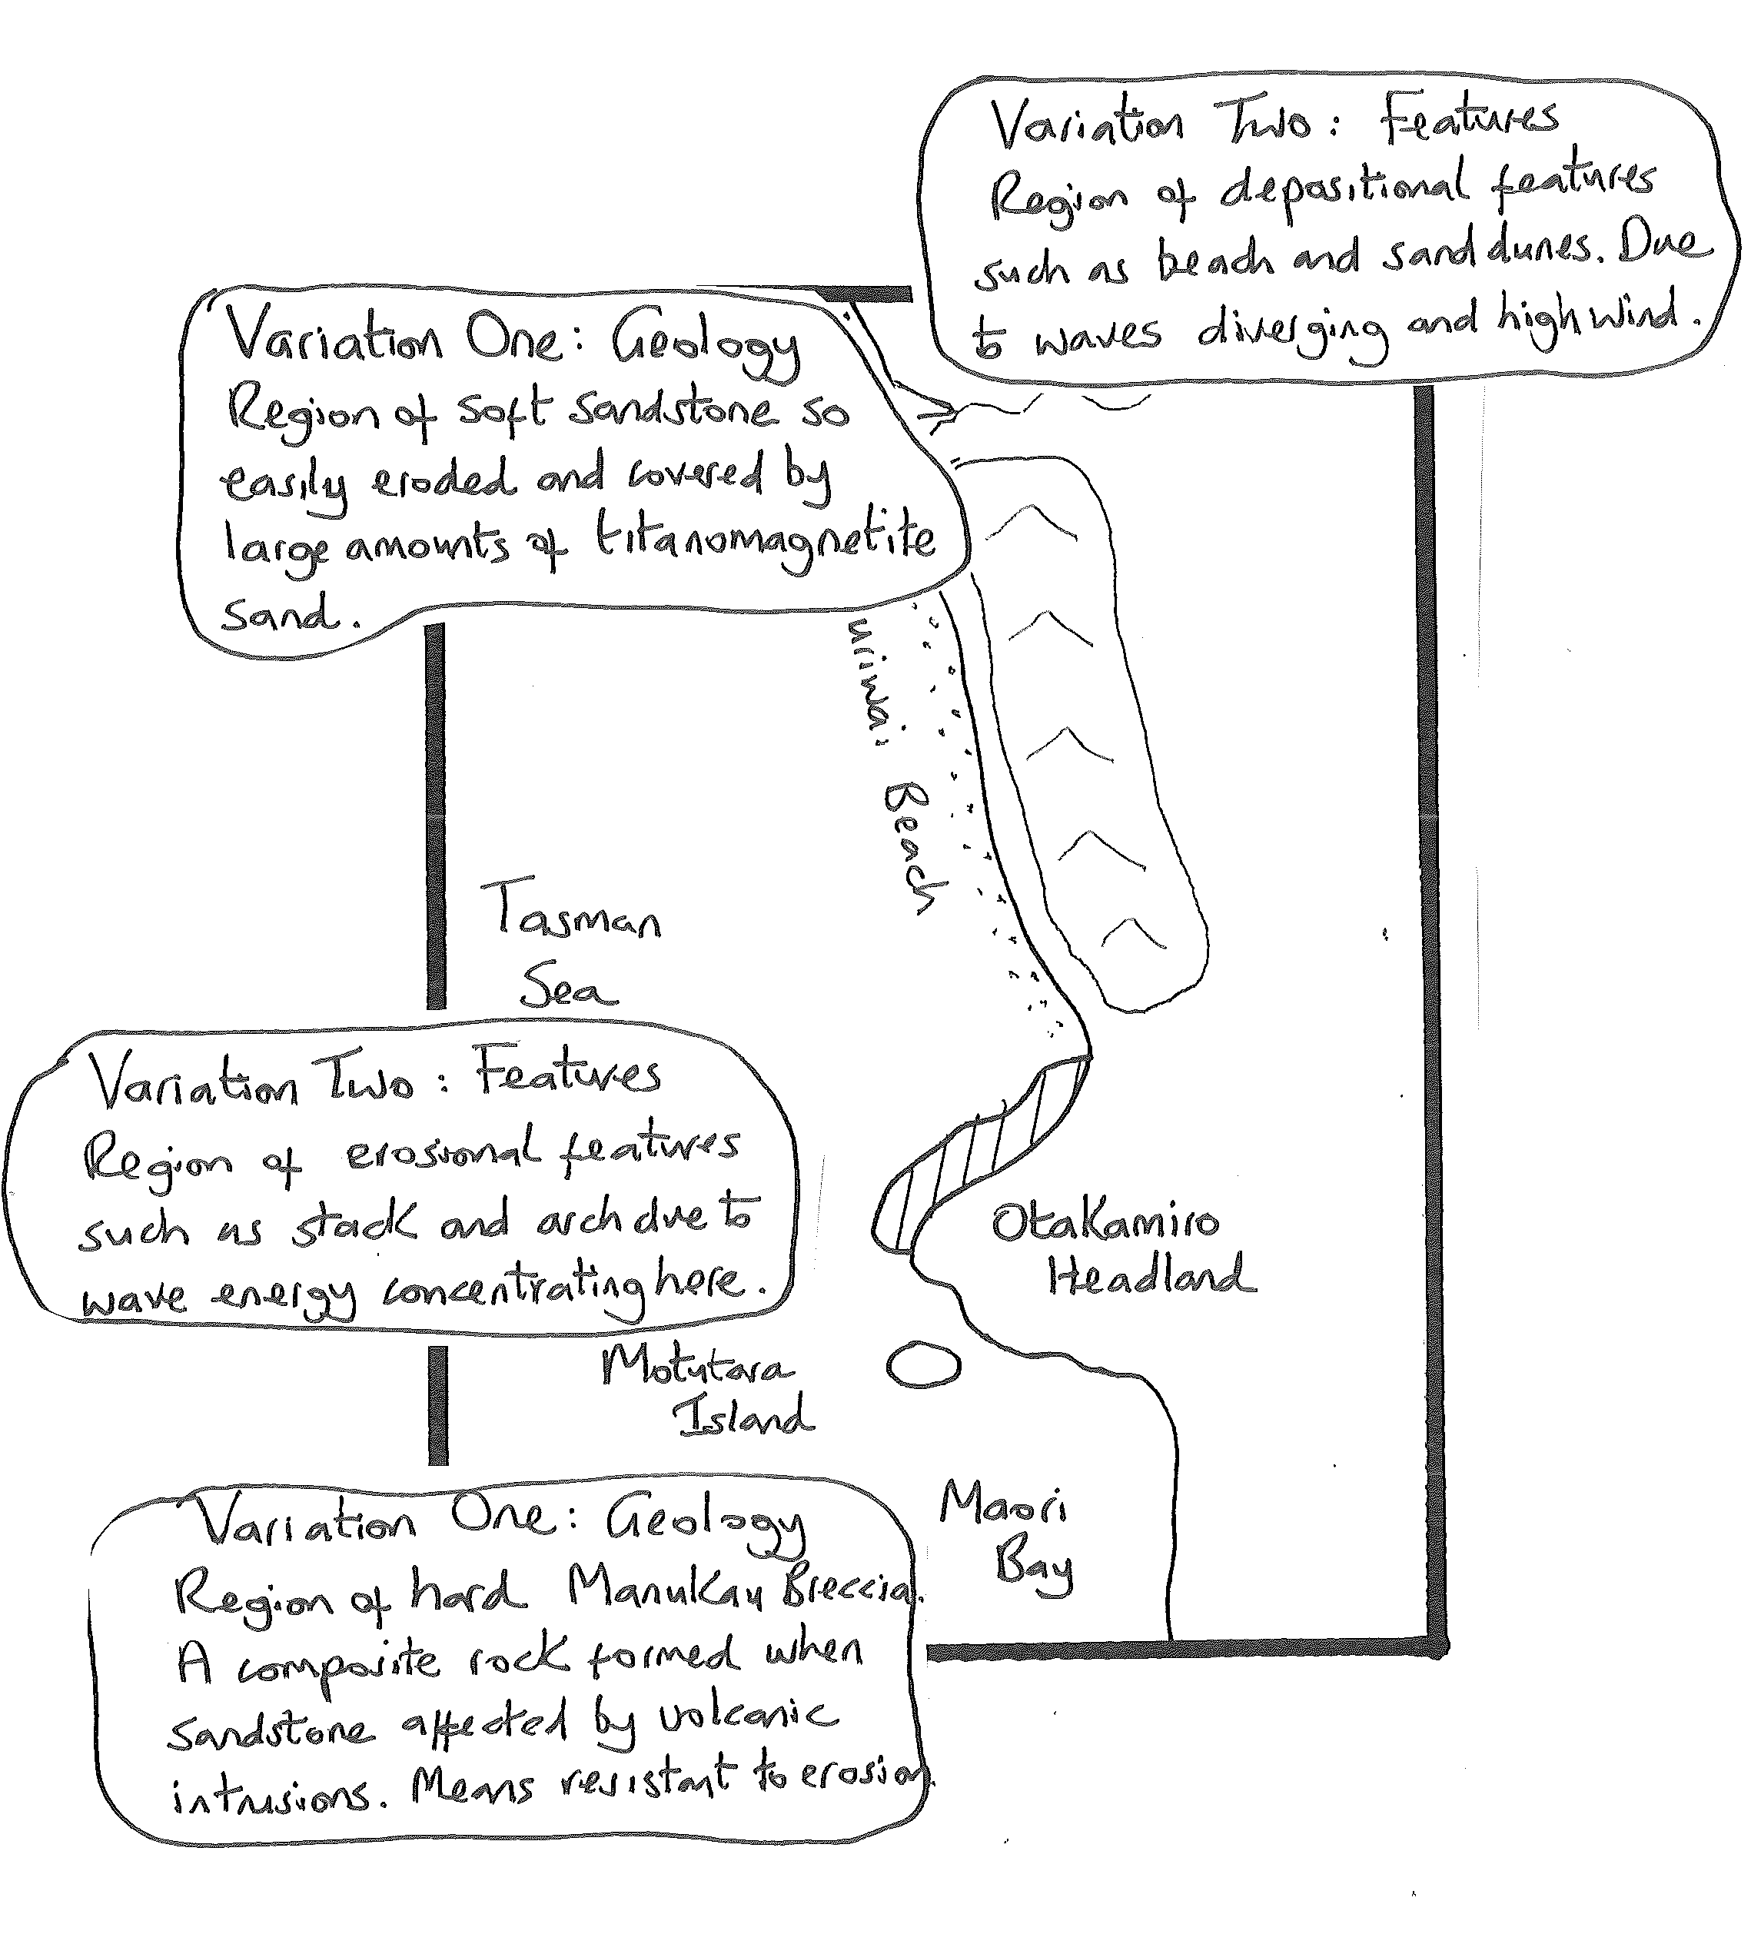
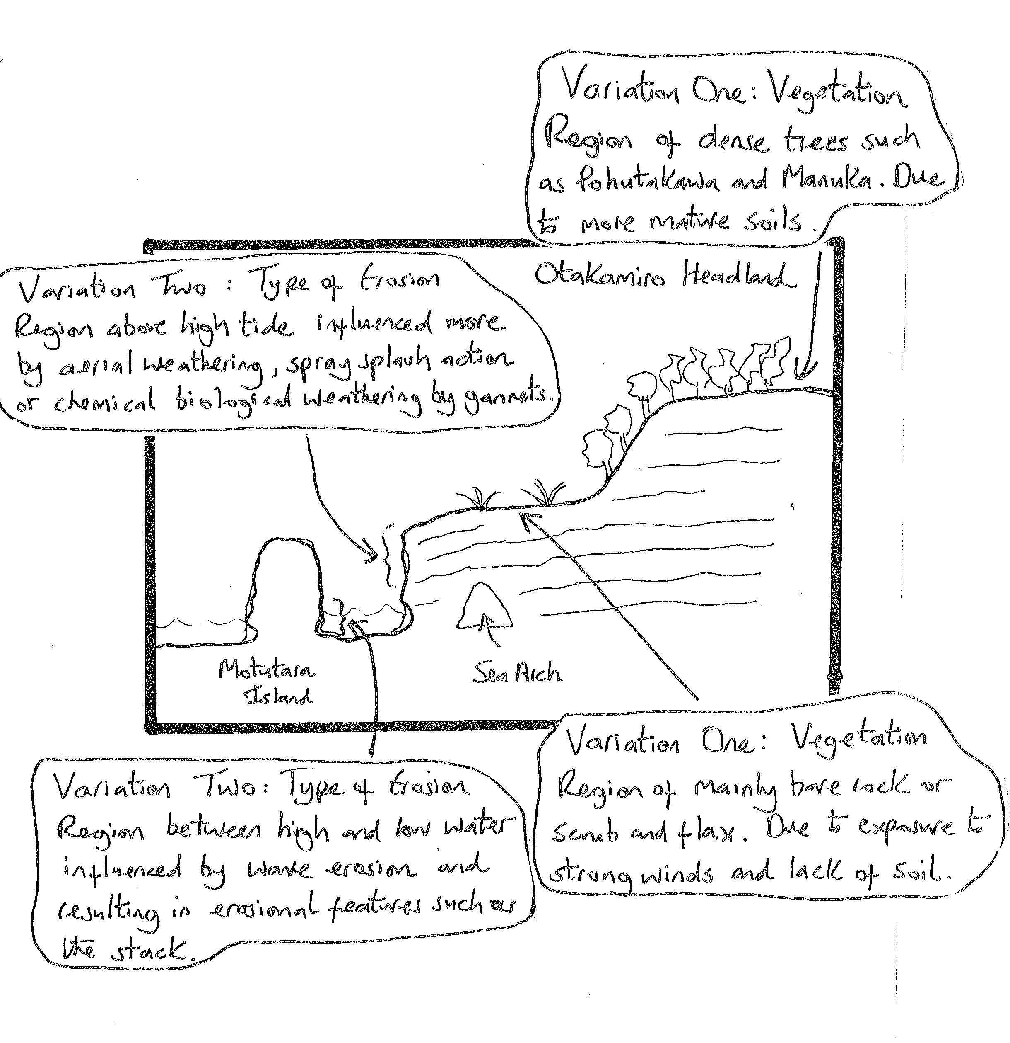
STAGE 7: ADD CONVENTIONS

It is important that you use the correct conventions at this level. If the question mentions mapping conventions they are essential or you risk not achieving if you forget these. These include (think FACKTS):

F rame – put a frame to show the boundary to your map/diagram
A rrow North – to show a maps orientation or the compass direction for a cross section.
C olour – try to use colour to differentiate different characteristics like blue for water, brown for mountains, green for forests, yellow for sand and red for settlements.
K ey – If you have used any symbols then add a simple key.
T itle – say where the map/diagram is of and what it is showing. It is good practice to take this from the question.
S cale - You MUST include a scale even if approximate. It is not enough to say ‘scale unknown’. Learn the distance between 2 features in reality. In this case the rock platform is approx. 400m long. If I measure this distance on my map I can draw a line this long as a linear scale. The same principal can be applied to a cross section. Learn what the distance is from one side of your environment to the other and the height of main features as a guide.

While this sheet is in black and white it is a useful skill to use coloured pencils in your externals. This is not to make it look nice but because colour acts as a quick, effective way of distinguishing different type of features. It is why you are told to bring some coloured pencils to the assessment.

Avoid block colouring features. If I were to colour in each of the patterns I have drawn it would take ages. It is as effective and much quicker to draw lines using a different colour. It takes a lot less time and is just as effective. Your annotated diagram is now complete!

A finished map would look like:

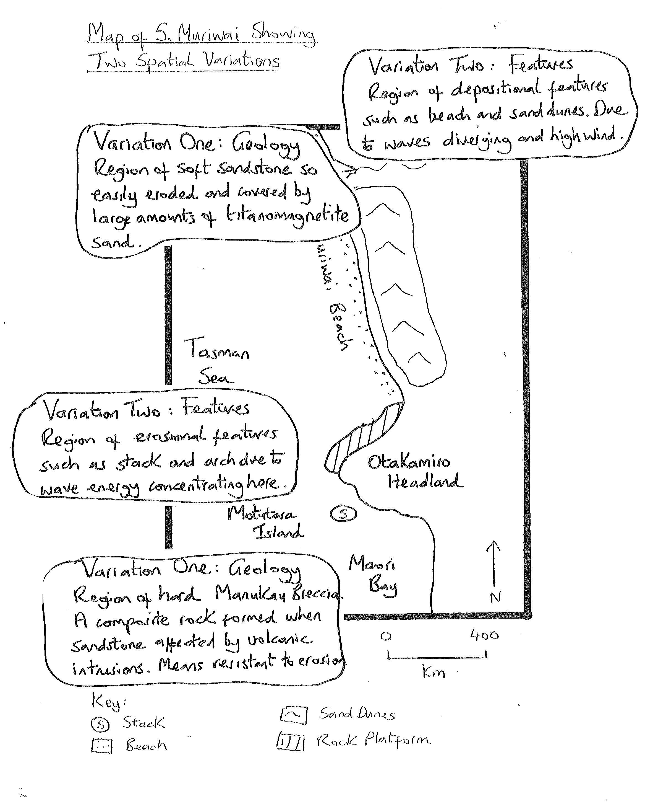

A finished cross section would look like;

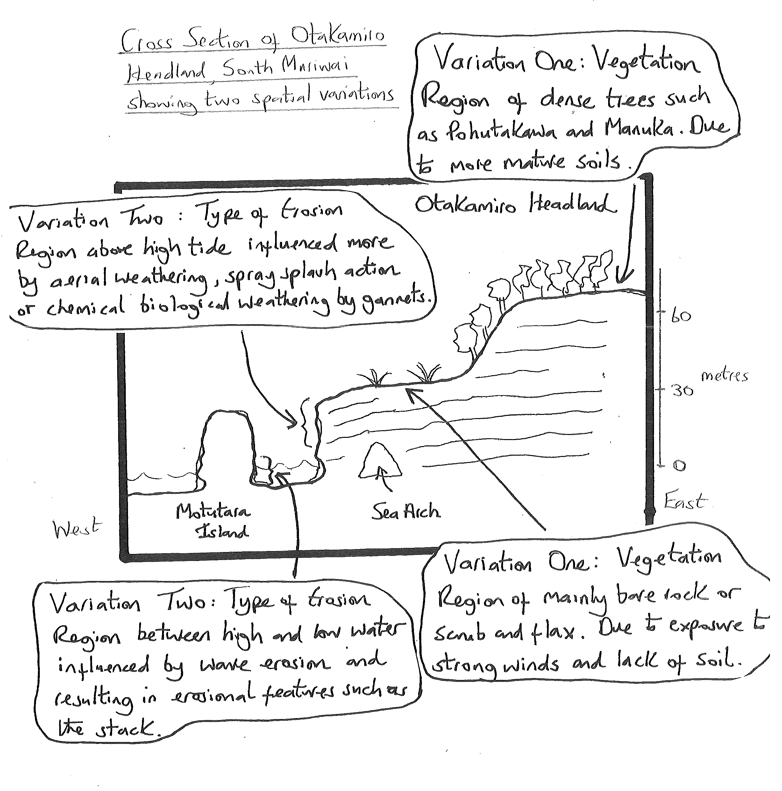

Jane Evans
Northland/Auckland/Central North Geography facilitator

Margaret Leamy
Lower North Island/South Island Geography facilitator

