GEOGRAPHY TIPS FOR STUDENTS

DOING DIAGRAMS IN L2 EXTERNALS

Geography is a spatial subject and so the ability to show information in different ways is important. It is often said that a picture shows a thousand words so if you can replace all those words with a diagram go for it! As a result geography assessments try to incorporate information in both writing and visual formats so you need to be competent at both! If you are not an artist do not worry. You are not being marked on your ability to draw well but on how you show the information.

WHAT IS A DIAGRAM?

The word diagram is often used in assessment, as this is a big umbrella term that includes any kind or visual or non-written information. There are 4 main types of visuals you can do:
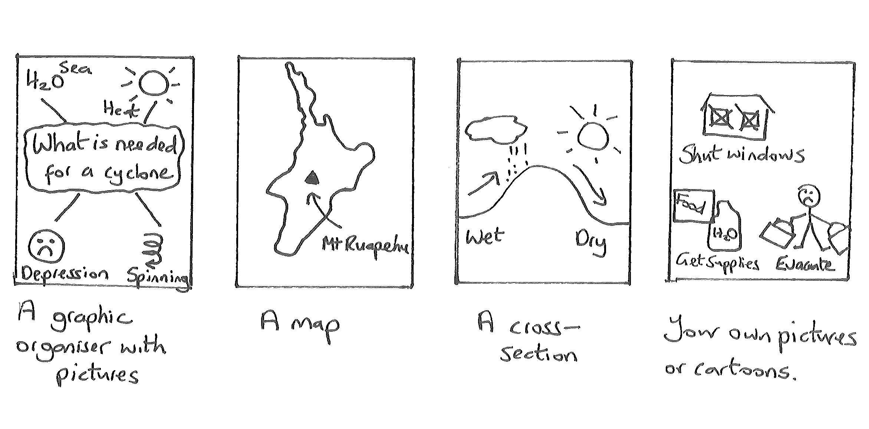Some questions may ask specifically for a map or cross section while other use the more general term of ‘a diagram’ that leaves it up to you. It is important that you read the question to determine where the visuals are to be included. These occur as either:

- A separate map, diagram or series of diagrams question – in this case it is important you follow the rules.
- To support an essay or written answer – spaces are not provided for these diagrams so simply draw a box on the lines provided. Such diagrams can be very small or rough and do not need to be as accurate such as including conventions.

So what are the rules with a diagram? This sheet has been set out in easy to follow stages to show you how to answer a separate diagram question.

STAGE 1: READ THE QUESTION

Your diagram is there to answer a question. It is therefore important to read the question carefully and translate what you need to do in your own words. As an example take the question:

(a) Draw an annotated map to explain 2 spatial patterns of natural characteristics that occur in your natural geographic environment.

This question is about how and why 2 characteristics (to do with relief, soils, vegetation or climate) are like this here but are different in another location.

It also pays to see if this is an (a) question as if it is read the (b) before you start. Often the diagram will need you to identify something that you can write about in more detail in the (b) part. If there is no (b) part then this will have to include a lot more detail.

STAGE 2: PLAN YOUR ANSWER

Before you start drawing PLAN how you are going to do this. If we break this question down we need to:
- Decide what 2 characteristics to show
- Decide on 2 places where each of these is very different
- Since the instruction word is ‘explain’ you need to say why they happen in each place
- Show how it is linked to a specific environment.

As an example let us imagine you are answering this using the Tongariro Volcanic Centre (TVC). I need to choose 2 patterns that I can both clearly show on a diagram and write about extensively to explain them in part (b). It is also a good idea to check they are due to different factors so you have more to write about in part (b). In this case you may choose:

- Vegetation differences (forests on West side compared to desert on East side)
- Relief (steepest where volcanism erupts via craters and less steep away from this)

STAGE 3: DRAW A BASE DIAGRAM
The next step is to produce a base diagram. You need to decide on the best way to show this information. Maps are generally the best way to show patterns such as this but other visuals such as a cross section would also be acceptable. Only use pictures and cartoons for questions where this is not appropriate such as the changing perceptions of people over time. Once you have decided draw the base outline of what you want to use

Drawing maps is much easier if you are using a coastal environment as the coastline can give a definite boundary. If it is an inland region such as the TVC it is much harder. Work out the features you can include that gives the area a sense of identity. In this case the mountain peaks, lakes and rivers will show important features of the natural environment. You can include some cultural features if they help identity the region but avoid going overboard with this. A busy map is hard to read and wastes time if the information is not essential.

For a cross section learn the approximate shape across your environment. Practice drawing both a map and a cross section of your large landscape, so that you can then choose which fits the question best.

When drawing your base outline use a pencil first. It is difficult to get it correct the first time so this allows you to easily change it until you are satisfied. Once you are satisfied you can go over it in pen. A base outline for both a map and a cross section to answer the question would look like:
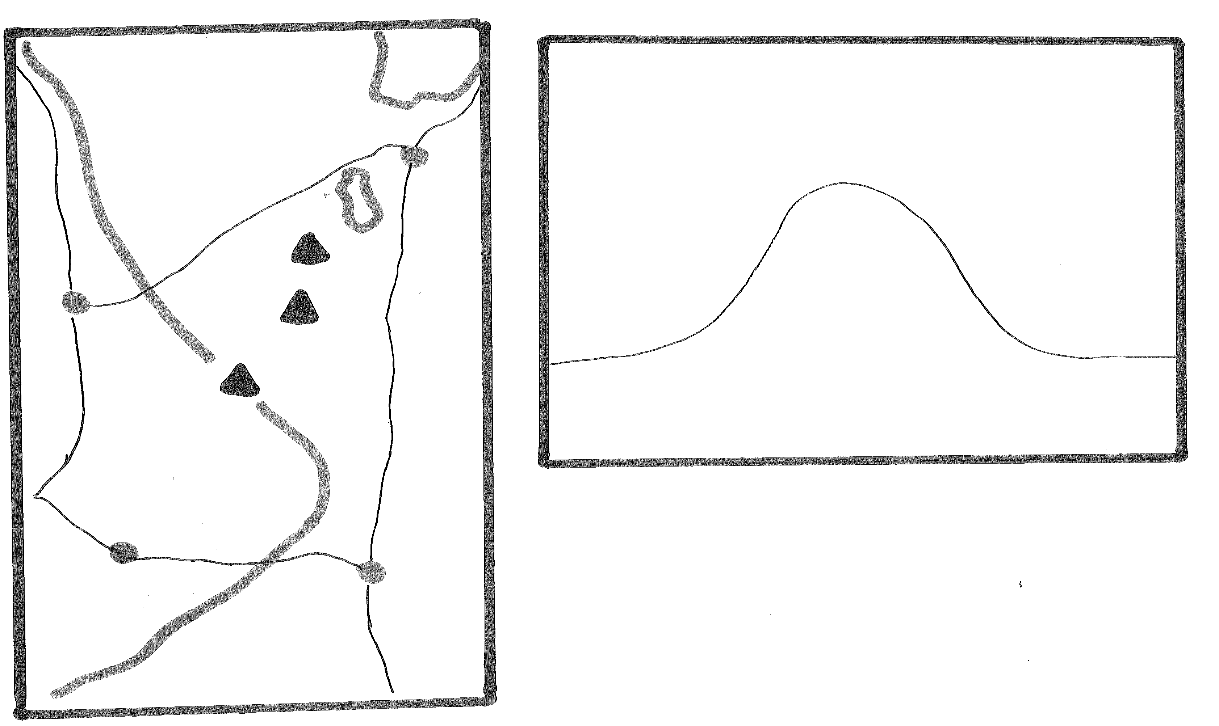

STAGE 4: ADD LABELS

Next it is important to link this diagram to an environment. You can do this by adding some names of places – easier to do in the case of a map but still possible on a cross section. Alternatively include this in the title or better still do both! Labels mean single words.

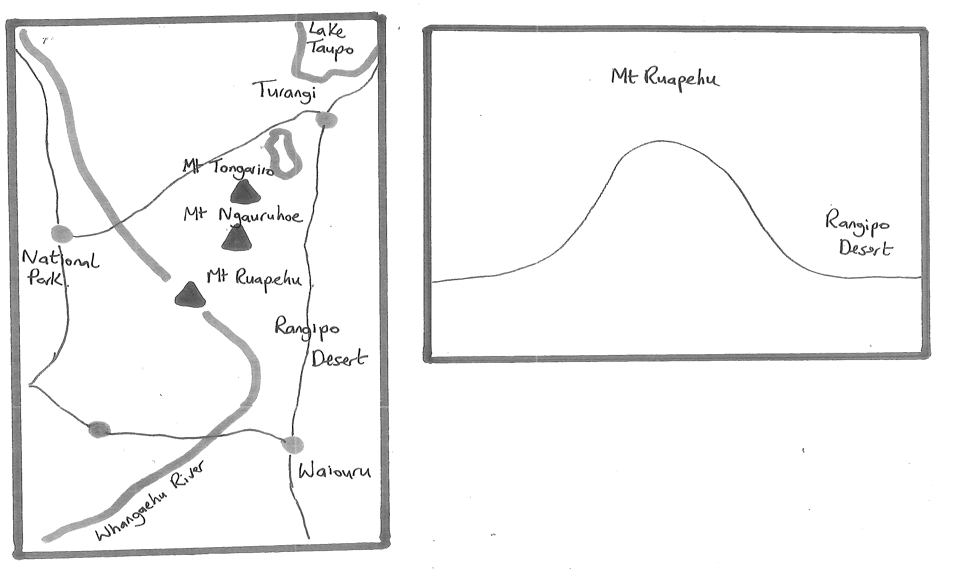
STAGE 5: ANSWER THE QUESTION
The next stage is to adapt your base map to answer the set question. Our example requires you to show 2 spatial patterns. These would look like:

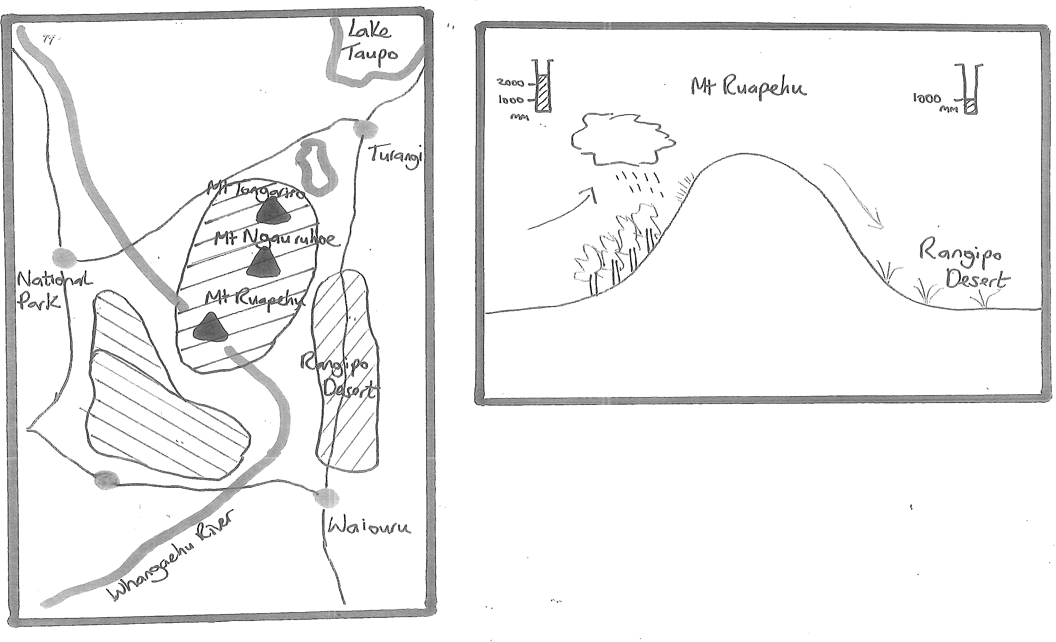

STAGE 6: ANNOTATE THE ANSWER
While you may understand what your diagram is showing to answer the question it may not be so obvious to a marker. This is why you are asked to annotate them. This means to put notes or simple sentences around your diagram that explain them. For example for a map:

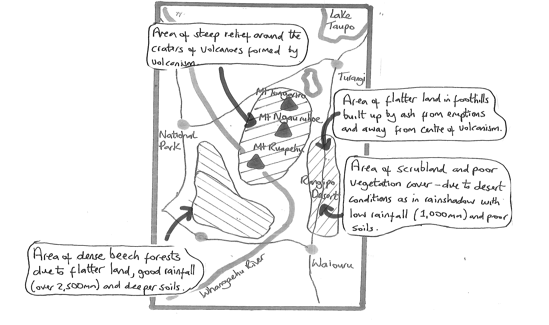
For a cross section:

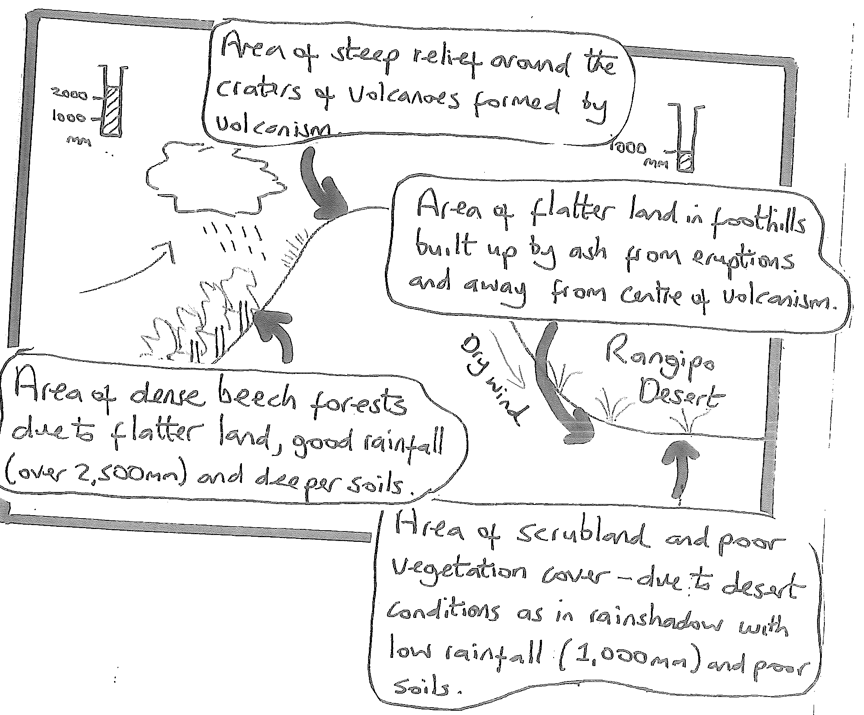

The notes can be either written on the map or linked around it using arrows as shown. If you can add some statistics onto your annotations as shown in this case do so. Not only does this link it to that environment but it also provides the detail that can gain you higher marks.

Check that your annotations answer the set question. Here you must ‘explain’ so check you use words that mean this in your answer such as ‘due to’.

STAGE 7: ADD CONVENTIONS

It is important that you use the correct conventions at this level. If the question mentions mapping conventions they are essential or you risk not achieving if you forget these. These include (think FACKTS):

F rame – put a frame to show the boundary to your map/diagram
A rrow North – to show a maps orientation or the compass direction for a cross section.
C olour – try to use colour to differentiate different characteristics like blue for water, brown for mountains, green for forests, yellow for sand and red for settlements.
K ey – If you have used any symbols then add a simple key.
T itle – say where the map/diagram is of and what it is showing. It is good practice to take this from the question.
S cale - You MUST include a scale even if approximate. It is not enough to say ‘scale unknown’. Learn the distance between 2 features in reality. In this case Waiouru to Turangi is approx. 60km. If I measure this distance on my map and divide it into 4 I can draw a line this long that is 15km. The same principal can be applied to a cross section. Learn what the distance is from one side of your environment to the other and the height of it as a guide.

While this sheet is in black and white it is a useful skill to use coloured pencils in your externals. This is not to make it look nice but because colour acts as a quick, effective way of distinguishing different type of features. It is why you are told to bring some coloured pencils to the assessment.

Avoid block colouring features. If I were to colour in each of the patterns I have drawn it would take ages. It is as effective and much quicker to draw lines using a different colour. It takes a lot less time and is just as effective. Your annotated diagram is now complete!

A finished map would look like:

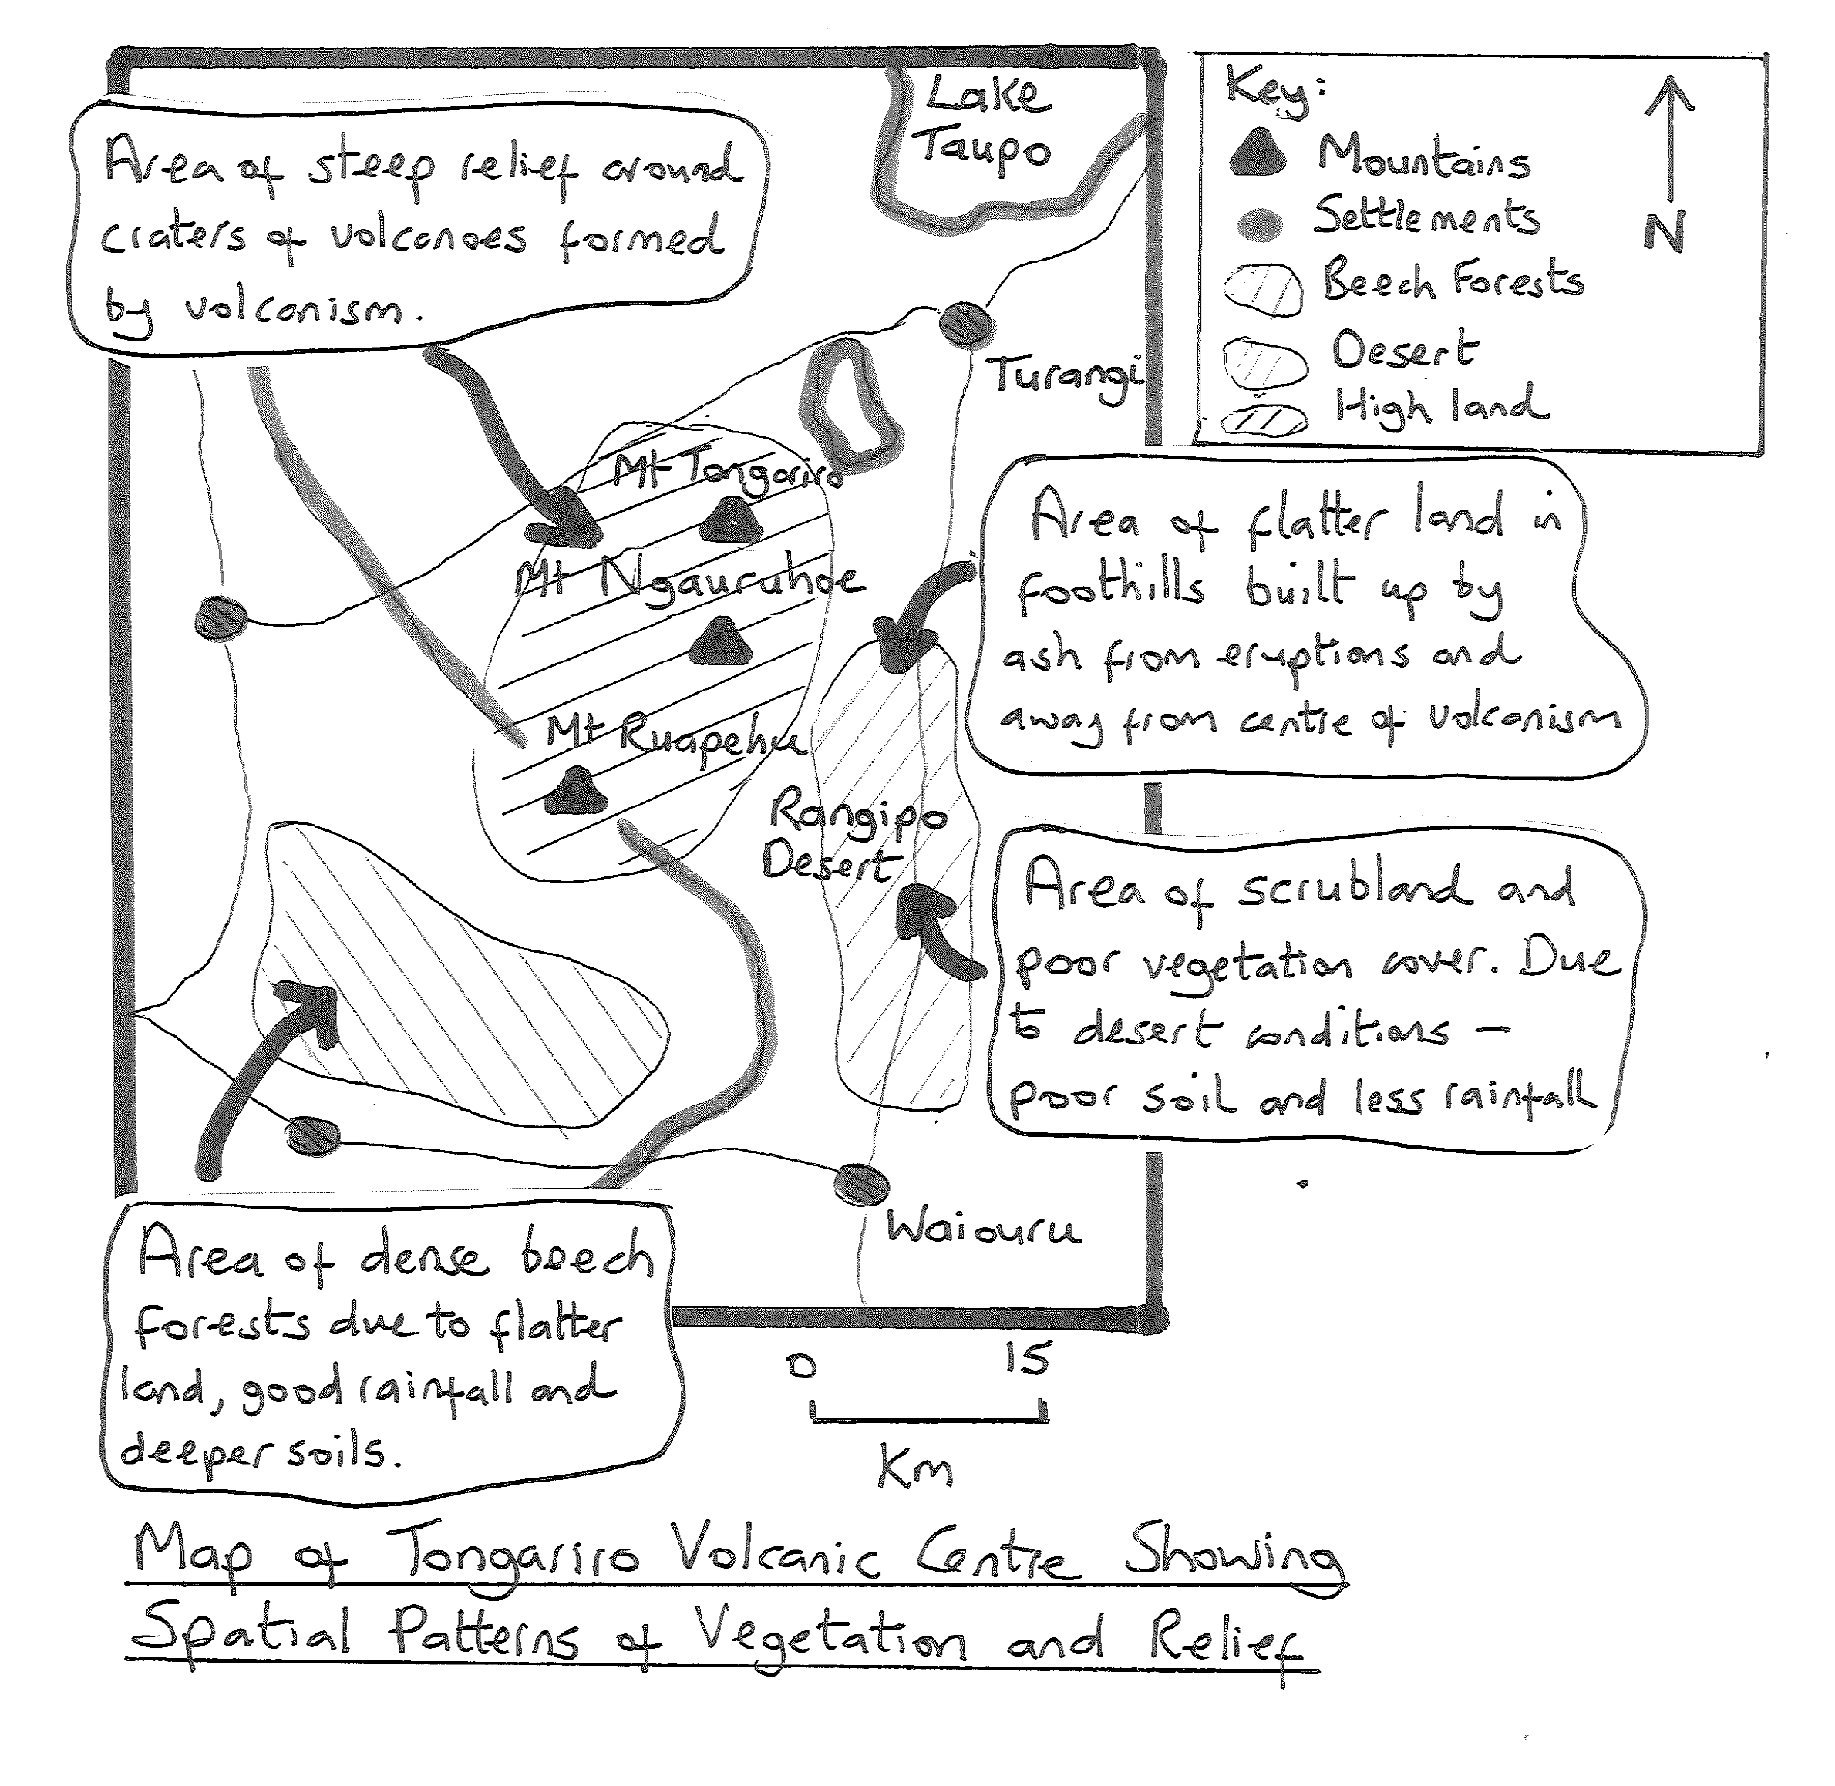

A finished cross section would look like;

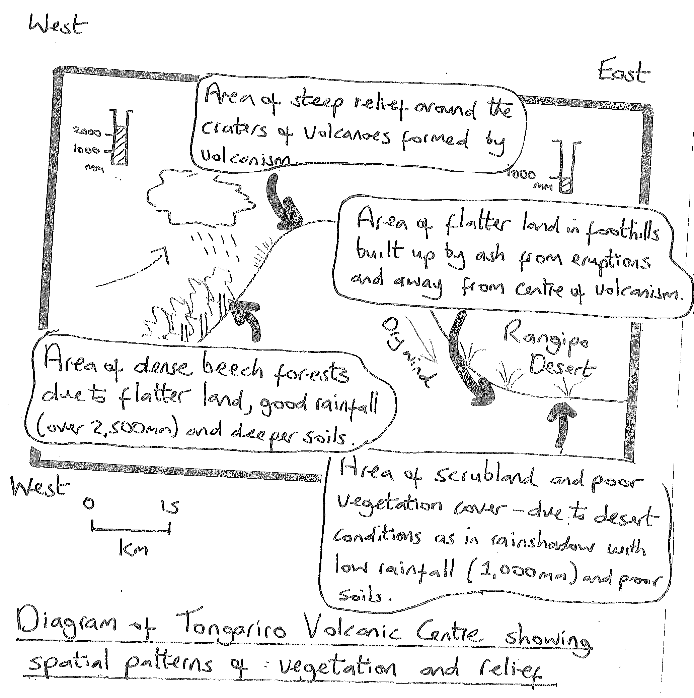

Jane Evans
Northland/Auckland/Central North Geography facilitator

Margaret Leamy
Lower North Island/South Island Geography facilitator

