QUESTIONS TO PREPARE FOR NCEA GEOGRAPHY TOPIC EXTERNALS

LEVEL 1

EXTREME NATURAL EVENTS

Vulnerability:

- Draw a fully annotated (labelled) diagram(s) to show the natural AND cultural characteristics that make the environment of your case study (studies) vulnerable to your named extreme natural event.
- Fully explain how the natural AND cultural characteristics make the environment of your case study (studies) vulnerable to your named extreme natural event.
Include specific evidence from your case study (studies) and refer to the diagram(s) that you have drawn to support your answer

How ENE is produced:

Fully explain the natural processes that operate to produce your chosen extreme natural event(s). Include a combination of notes and diagrams in your answer.
Use specific evidence from your case study (studies) to support your answer

Effects on Natural Environments:

(a) Draw an annotated (labelled) diagram(s) to show the effects of your extreme natural event on the natural environment of a named case study.

(b) Fully explain how your named extreme natural event has affected the natural environment. Include specific evidence from your case study (studies) to support your answer

Effects on cultural environments:

(a) Draw an annotated (labelled) diagram(s) to show the effects of your extreme natural event on the cultural environment of a named case study.

(b) Fully explain how your named extreme natural event has affected the cultural environment of your case study.

How people respond:

Fully explain ONE immediate response AND ONE long -term response to the effects of your extreme natural event, by TWO individuals, groups or organisations.

POPULATION:

Population Distribution:

- Draw an annotated (labelled) map to show the population distribution (where the population is located) in your named country or region.
(b) Fully explain why the population is located where it is in your named country or region.

Population Diversity:

(a) Identify which of the age-sex pyramids shown below is typical of the country or region you have studied. From this name TWO characteristics about the population structure this age-sex pyramid shows.
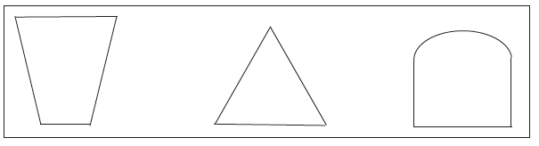

(b) Fully explain these TWO characteristics of the population structure of the named country or region you have studied.

Migration and Mobility:

(a) Draw an annotated (labelled) diagram or series of diagrams to show the push and pull factors that are causing people to move from one place to another.
Use specific evidence from your case study (studies) to support your answer.

- Fully explain the different effects that migration has had on the people in the origin place and the destination place.
Use specific evidence from your case study (studies) to support your answer.

OR

(a) Choose ONE type of migration that that is significant in the region or country you have studied from the list below.
- Movement one part of a country to another by choice (Internal)
- Movement from one country to another by choice (External)
- Forced Movement from one country to another (External)

(b)Fully explain the current trends in this type of migration and the consequences this has had on your selected case study region or country.

Change over time:

Fully explain how and why the population totals of your selected region or country has changed over time

OR

- Draw an outline of the age-sex pyramid of your selected country or region at some stage in the past and a similar diagram to show this age-sex pyramid today.
- Describe and explain the differences that have occurred in the age-sex structure in your selected country or region during this time period.

OR

- The Demographic Transition model below shows changes in natural increase. Identify where on this model your selected country or region occurs.

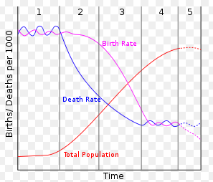

- Fully explain by giving reasons why your selected country or region is at this stage with natural increase and not another.

Population Sustainability:

Name a country or region whose population you have studied that has EITHER an ageing OR a youthful population. Fully explain the issues your named country or region faces in supporting EITHER an ageing OR a youthful population in the longer-term.

OR

- Draw an annotated (labelled) diagram or series of diagrams to show why your selected country, region or place has had to consider different ways to ensure the environment is able to support a population in the longer term.

- Fully explain the different ways that have been used by your selected country, region or place to ensure that the environment is able to support a population in the longer term.
Use specific evidence from your case study (studies) to support your answer

