Huge blow if eruption hit factory zones NZ Herald 11 May 2015
A catastrophic volcanic eruption in Auckland's industrial heart could have an economic impact of up to $10 billion in the first year and knock out a large chunk of the city's GDP.
A team of researchers used a recently developed model, which drew on fresh data to recalculate the vulnerability to volcanic explosions in different parts of the city, to measure how and where a large eruption could inflict economic damage.
Much of Auckland is at risk - more than 50 volcanoes lie beneath a field stretching across 360sq km - and more than one million people live on areas where an eruption could occur.
But it is in the core industrial hotspots of Penrose, Onehunga, Otahuhu and East Tamaki where such a disaster would be most damaging to Auckland's economy, costing on average $8.3 billion (in 2007 dollar terms) in lost GDP from businesses, factories and supply chains being taken out.
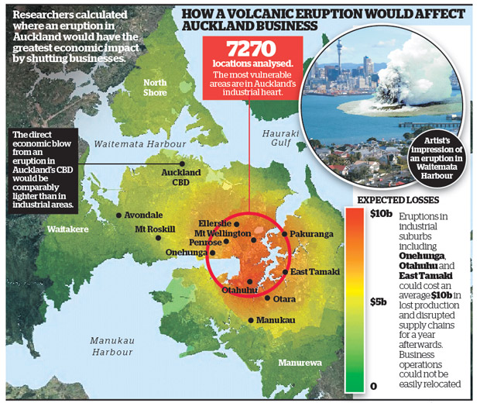
The study worked off estimates that anticipated an eruption that would stop businesses operating within zero to 3km of the vent, mass relocation of enterprises within 3-5km of it, and other effects including ashfall and lava flows wreaking havoc within 5-7km.
Dr Garry McDonald, a study co-author and director at Auckland consultancy Market Economics, said much of the industrial belt was particularly vulnerable to eruptions.
"A lot of these areas have plants and machinery which you can't easily stop and start or relocate, so once they are out, they are out for a long period of time. It all quickly adds up."
Dr McDonald said even an average loss of $5.9 billion (in 2007 dollar terms) would be a heavy blow to Auckland's regional GDP, last estimated at more than $81 billion. The study also showed an eruption beneath the central business district - which previous research had estimated to take an enormous toll on GDP - would have a comparably lighter economic impact.
"In the CBD, you have many commercial services, but a lot of these can relocate, work remotely or recapture business at a later date by working harder at a later date," Dr McDonald said. While the study showed a clear argument to develop the city in a way that lessened economic vulnerability to natural hazards, this did not always meet with a current planning focus on making Auckland more compact, he said. Auckland Council executive Penny Pirritt said the council's focus on eruptions had to be on early warnings and situation monitoring. "The probability of a volcanic eruption is far less of a concern than other issues when we consider zoning land for industrial activity."
Volcanologist: You can never say never
What are the chances of an eruption in Auckland? The threat of a volcanic blast wreaking fiery havoc in a quiet Auckland suburb like St Heliers or Remuera may seem the stuff of a big-budget disaster movie. But there is always a chance - though slim, at about one in 4000 each year - that it could become a reality. "This rate is slowly creeping up as each year goes by without an eruption, and although the number seems vanishingly small, it is by no means zero," Auckland University volcanologist Professor Shane Cronin said. Geologically, the Auckland Volcanic Field - the large area of the city in which more than 50 volcanoes lie - is an infant. It has erupted only for a quarter of a million years and we know that similar fields in New Zealand and in other parts of the world can keep erupting for at least a million years, if not 10 times longer. Also, the rates of eruption in Auckland have been its highest ever in the past 50,000 years, which means that its pulse is quickening. "These features tell us that the Auckland field is still very much alive, and although dormant since its last eruption 500 years ago at Rangitoto, new eruptions could occur in any location across the main metropolitan city area," Professor Cronin said. When it comes to new eruptions in Auckland, magma driving them is sourced anywhere from 80km to 120km deep. The long journey to the surface would likely give off warning signals such as quakes and gas release, allowing authorities enough time to enact evacuation plans and isolate the likely location of the vent.
"While past patterns of activity appear to highlight zones of higher probability of eruption, in principle, we would not know where the eruption may be without such precursory signs of where the magma rises."
- NZ Herald

