DEMOGRAPHIC TRANSITION MODEL

The Demographic Transition Model shows what might happen to the birth rate, death rate and natural increase over time. The model is often used to describe population changes in industrialized countries and suggests that all countries will pass through similar demographic changes, given time. The stages of the model are closely linked to a country’s level of economic development.
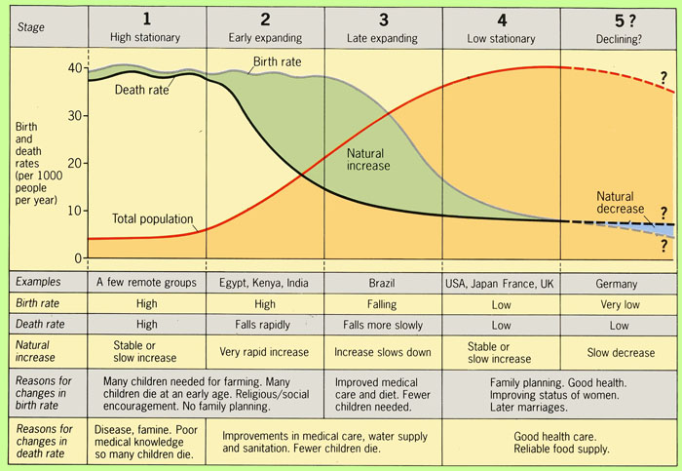

http://www.youtube.com/watch?v=jxUD8E-qbyI (Demographic Winter)

- In stage one, before industrialization, birth rates are high while death rates are also high and fluctuating. Many diseases occur which cannot be controlled, and wars are common.
- In stage two, that of a developing country, the death rates drop rapidly due to improvements in food supply, medicines and sanitation, which increase life spans and reduce disease. Birth rates remain high. Population growth increases rapidly.
- In stage three birth rates begin to drop as countries become more developed and literacy becomes widespread. People begin to see the value of smaller families and learn how to use the contraceptives made available. Rapid urbanisation.
- In stage four there are both low birth rates and low death rates. Birth rates may drop to well below replacement level (as small families are seen as desirable) as has happened in countries like Germany, Italy, and Japan, leading to a shrinking population, a threat to many industries that rely on population growth. The large group born during stage two ages creates an economic burden on the shrinking working population.
- In stage five the population is in decline as death rates are higher than birth rates.

The demographic transition sees a change in the age composition of population pyramids.

Initially in the demographic transition there is a rapid rise in the younger age groups (babies and children). Later, as these persons grow older, the working age population comes to be a much larger proportion of the total population. Finally, as we see in Britain in recent times, the elderly population comes to be a larger component of the total population than in earlier times.

Activity: Using the statistics below, establish where each country would fit in the Demographic transition model. Justify your placement of each country on the model.

Population Statistics of various countries (Source: CIA 2011)
Country | Birth Rate  /1000 live births | Death rate  /1000 live births | Country | Birth Rate  /1000 live births | Death rate  /1000 live births
Niger | 50 | 14 | Mexico | 19 | 5
Japan | 7 | 10 | Taiwan | 9 | 7
Indonesia | 18 | 6 | Uganda | 47 | 12
China | 12 | 7 | France | 12 | 9
Australia | 12 | 7 | Swaziland | 27 | 15
Zimbabwe | 32 | 14 | South Africa | 19 | 17
India | 21 | 7 | U.A.E | 16 | 2

One of the effects of stages 2 & 3 of the Demographic Transition Model is that even after low and stable birth rates have been achieved, the population continues to grow for some time. This is because 20 years after a period of high birth rates the large proportion of children become a larger proportion of parents. Each set of parents will have only a few children but because there are more parents there will be more children and continued rapid population increase. The increase in population continues until there are fewer parents. This delayed effect is called Demographic Momentum.

Monsoon Asian Countries and the Demographic Transition Model
Around 1950, most Monsoon Asian countries were at stage 1 on the Demographic Transition Model. Since then all have moved along the development path, some more quickly than others. As a country becomes wealthier and its economy develops, its population structure changes.
- India’s youthful population has a falling, but still high, growth rate. The Indian government has been urging people to have fewer children for many decades – but many poor people cannot see the benefits.
- China’s population has a low growth rate. The Chinese government has been forcing people to have few children for many decades and so the median age is quite high, and rising. Death rates are quite low (and falling) as urbanization has led to greatly improved incomes and living standards.
- Japan’s ageing population is declining. In this wealthy, highly urbanized country birth and death rates are very low.

