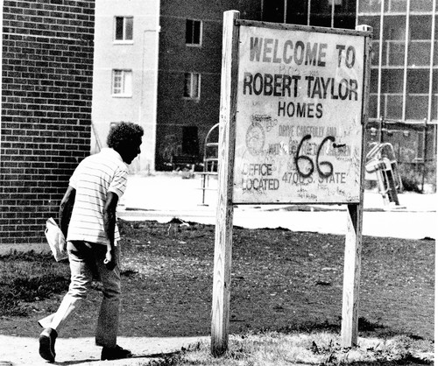
The Robert Taylor Homes Public Housing Development
The Robert Taylor Homes was a public housing development completed in 1962 and named for after Robert Taylor who was an African American activist and a Chicago Housing Authority (CHA) board member.
At one time, it was the largest public housing development in the country, and it was intended to offer decent affordable housing.
"This is a great thing for the city. It provides decent housing for fine families."
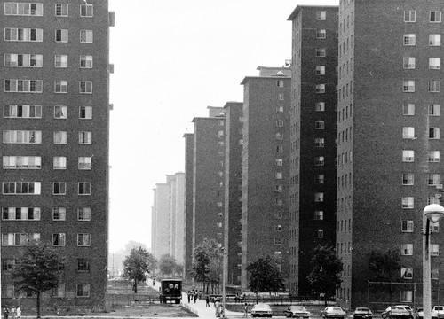
It was composed of 28 high-rise buildings with 16 stories each, with a total of 4,415 units, mostly arranged in U-shaped clusters of three, stretching for three kilometres. It formed a kind of concrete curtain for traffic passing by on the nearby Dan Ryan Expressway. Although it was meant to be an improvement over the slums they replaced, the buildings turned into hot zones for a host of social problems. The housing project was supposed to be a ‘half way house’ on the road to a better life, but it quickly became a dead end for most residents. Robert Taylor Homes was America's largest public-housing project and evolved into an emblem of failure.
The Robert Taylor Homes
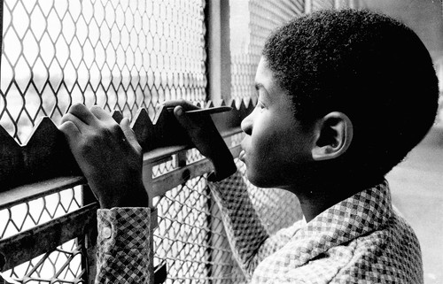
Planned for 11,000 inhabitants, the Robert Taylor Homes housed up to a peak of 27,000 people. The housing area was one of the poorest in the USA. With drab exteriors and chain-link fences on the balconies, Robert Taylor Homes came to be seen by many residents and by outsiders as prisons for the poor. At one point 95% of the 27,000 residents were unemployed. 40% of the households were single-parent, female-headed households earning less than $5,000 per year. About 96% were African-American. Residents were twice as likely to be the victims of serious crime as other Chicagoans. Many of the drab, concrete high-rises were blackened with the scars of arson fire. Robert Taylor Homes faced the same problems that doomed other high-rise housing projects in Chicago. These problems include narcotics, violence and poverty. The city's neglect was evident in littered streets, poorly enforced building codes, and very few amenities.

The rates of violent crime and gang activity in the Robert Taylor Homes were among the highest in Chicago. All the Major Chicago gangs: The Black Kings, the Sharks, the Black Disciples, Vicelords, Black P. Stone Nation, and Mickey Cobras all had strongholds in the housing development.

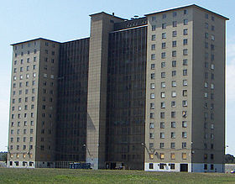
Police reported that high number of murders were the result of gang ‘turf wars’, as gang members and drug dealers who fought over control of neighbourhoods. The Chicago Housing Authority (CHA) has estimated that $45,000 in drug deals took place daily. Former residents of the Robert Taylor Homes have said that the drug dealers fought for control of the buildings. On one particular weekend, more than 300 separate shooting incidents were reported in the vicinity of the Robert Taylor Homes. Twenty-eight people were killed during the same weekend, with 26 of the 28 incidents believed to be gang-related.
The Robert Taylor Homes were built at a time when racial and economic equality were improving. However housing projects like this in Chicago and many other cities were sowing the seeds of an underclass of mostly black citizens who seemed consigned to live their lives in these vertical ghettos. These housing projects were not proving to be a stopping place on the way to a better life.
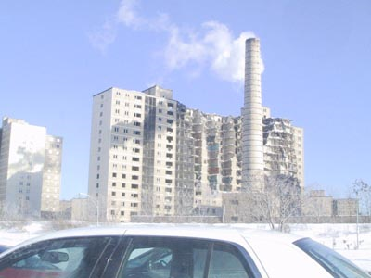
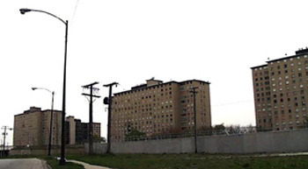
The idea that places like Robert Taylor Homes would be humane replacements for slums was starting to crack. Many of the high-rise complexes were poorly constructed. The concentration of the poorest of the poor transformed Chicago's public housing into a national emblem of failure.

Admitting the failure of densely packed high-rises in 1993 it was decided to replace all Robert Taylor Homes with a mixed-income community in low-rise buildings. In February 2002, families living in the Robert Taylor Homes public housing development were given a 180 day notice of eviction. The community that had been their home for generations would be demolished. “Within five years,” the mayor said, “the city hoped to eliminate most of the worst apartment buildings and replace them with new housing.” The Chicago Housing Authority (CHA) moved out all residents by the end of 2005. On 8 March 2007, the last remaining building was demolished.

The film ‘Dislocation’ chronicles the lives of tenants in one Taylor building as they move through the six-month relocation process in 2002.

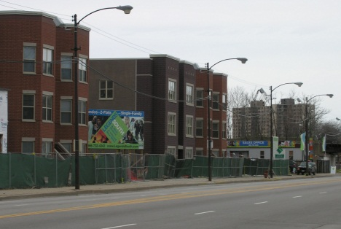
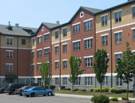
A year after she left Chicago’s notorious Robert Taylor Homes public housing development, 30-year-old Lee Henderson said she was ready to return. “I’d rather live in Robert Taylor,” she answered when asked whether she would prefer to live among private-market neighbours or public housing residents. “Poor people help poor people. They have no one else, so they know how to help each other get by.” Leaving Robert Taylor in 2002 meant saying goodbye to neglectful police and violent gangs, but it also meant leaving behind all of these invisible social supports. Yet this single mother of two, who has lived most of her life in public housing, says quite confidently that she prefers to inhabit the dark, distressed corridors of Robert Taylor. Sitting in the house that she moved into after leaving Robert Taylor, where rats are coming up through the vent from the basement, and where the landlord has repeatedly refused to make repairs, it is easy to understand why. Soon after stating her desire to return to Robert Taylor, Henderson says, “It was not supposed to be this way. They told us they were tearing down the buildings ’cause we would have a better life. I’m still waiting.”

As of 2007, a total of 2,300 low-rise residential homes and apartments, seven new and renovated community facilities, and a number of retail and commercial spaces are to be built in place of the old high-rise buildings. The development costs are expected to total an estimated $583 million. Part of the redevelopment is the renaming of the area to ‘Legends South’.

INTRODUCING LEGENDS SOUTH
Legends South is more than just another residential development. It is one of the largest revitalization efforts ever undertaken in the City of Chicago that, when completed, will include nearly 2,400 new rental and home ownership units – and will remove the former super block configuration imposed by the former Robert Taylor Homes. This extraordinary development will stretch for two miles through the very heart of Bronzeville.

