Gentrification in Chicago

Might gentrification and the displacement of housing project residents contribute to instability in Chicago and its persisting high rates of violence?

In 1981, Chicago was divided into white, black, and "revitalizing areas". Gentrification was what was planned for the ‘revitalizing areas’. This 1981 document is a good guide to the gentrification that has occurred in the last few decades.

Chicago is undergoing massive spatial disruption, as gentrification and the tearing down of the CHA (Chicago Housing Authority) housing projects are displacing thousands and families and gangs as well. The displacement of gangs has contributed to violence as new turfs are fought over and gangs are de-stabilized. The impact of gentrification and community policing may be contributing to the re-segregation of Chicago and indirectly responsible for persisting high rates of violence.

Gentrification on the north and near west sides and the tearing down of the housing projects are disrupting traditional gang areas. The poor members of these communities and the gangs are begin displaced and are now concentrated on the far west and particularly the south side.

Chicago has become a dual city: one mainly white city located in areas close to the new economy with residents who have high levels of formal education and with moderate to high levels of income.
The other city is moving to the south and west. It is mainly Black, Latino, and poor. The ghetto has not disappeared in Chicago, but has persisted.

Chicago Low Income Housing Sites 1981

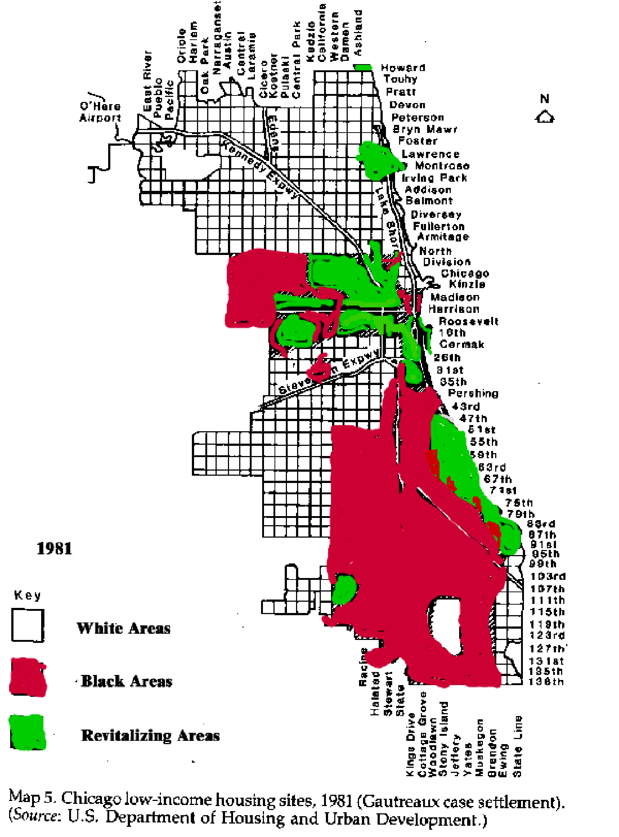

GENTRIFICATION WON'T MAKE THE GANGS GO AWAY

