Urban Pattern of Crime: Burgess’s Concentric Zone Model

During the 1920-30’s the Chicago School (a group of sociologists) were interested in urban problems and crime. They used the rapidly changing and diverse city of Chicago for their research. One of their main goals was to explain why social disorder occurred in different parts of the city and whether this lead to more crime.

Burgess’s concentric zone model of urban growth (1925) is based on the city of Chicago. He developed this model as part of the Chicago School’s research. The model divides urban areas into five concentric zones based on typical land use patterns.

Zone I - the central business district or Loop in Chicago is restricted to commercial uses.

Zone II - the Zone in Transition is a mixed area, where low-rent, slum residences are being replaced by businesses and factories.

Zones III-V - residential areas (Zone of Workingmen's Homes, Residential Zone and Commuters' Zone).

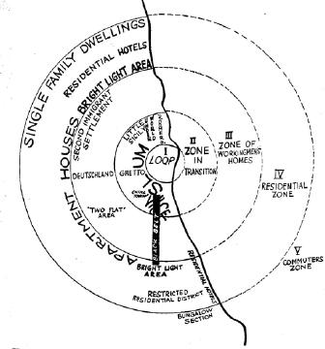 | 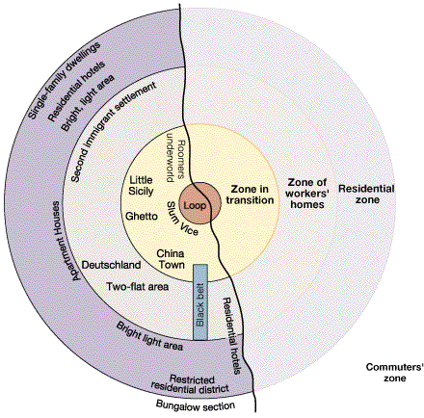
Burgess’s original concentric zone model of urban growth. | Updated version of Burgess’s concentric zone model of urban growth

Burgess believed that the model was useful for understanding change in the city. As the central business district (Zone I) expands, commercial uses increasingly invade the residential areas in the Zone in Transition (Zone II). Because residential properties in Zone II will eventually be sold for commercial purposes, landlords allow them to deteriorate. This, in turn, leads to an expansion of the transitional, slum area into Zone III and so on. This relates to the Tipping Process whereby as a neighbourhood deteriorates it ‘tips’ into an undesirable area and middle-class or affluent people leave the area and crime increases as gangs and undesirables become the social norm.

Studies in Chicago showed that the highest rates of crime were found in Zone I and Zone II of Burgess' model. As the distance from the CBD (The Loop – Zone 1) increased, the rates of crime steadily decreased with the lowest rates for the entire city appearing in Zone V.

Why does ‘Zone II: The Zone of Transition’ have lots of criminal behaviour?

- Highly populated and large turnover in immigrant population
- Immigrants become successful and move onto wealthier places and a new wave of immigrants arrive
- Social deprivation and lack of social order and lack of community
- the cheap slum-style housing
- community relationship break down people no longer share the social norms, values and beliefs
- lack of understanding about what is seen to be right and wrong

Lack of Community = Increased Crime
Burgess’s Concentric Zone Model:
What Is The Urban Pattern of Crime Today In Chicago?
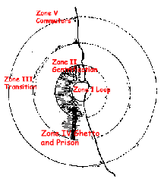
By the mid-1990s, a much different pattern had emerged. The Loop became a zone of gentrification* with the development of information industries and housing. This new middle class area spread out into the old "interstitial" gang areas (Zone II). This forced Hispanic and African American communities (ghetto) to relocate. The ghetto has moved southward and westwards, but it also has a new dimension (Zone IV). The Zone of Transition has now shifted to Zone III. The prison has many of the same functions as the ghetto -confinement and social control. Today the back and forth between prison and ghetto is a normal experience of many African American and gang members.

Notice the marked concentration of gangs on the west and particularly the south side in the ghetto areas. Gentrification on the north and near west sides and the tearing down of the housing projects are disrupting traditional gang areas with unknown long term consequences.
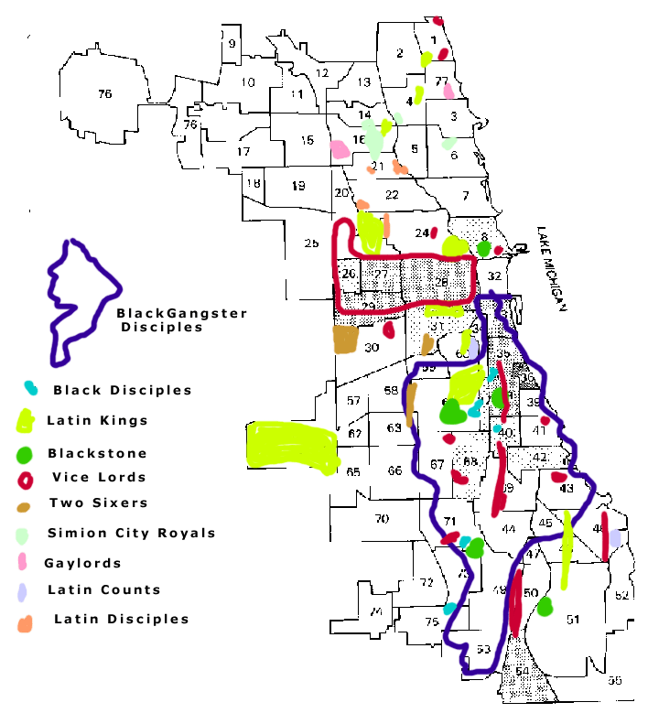 | 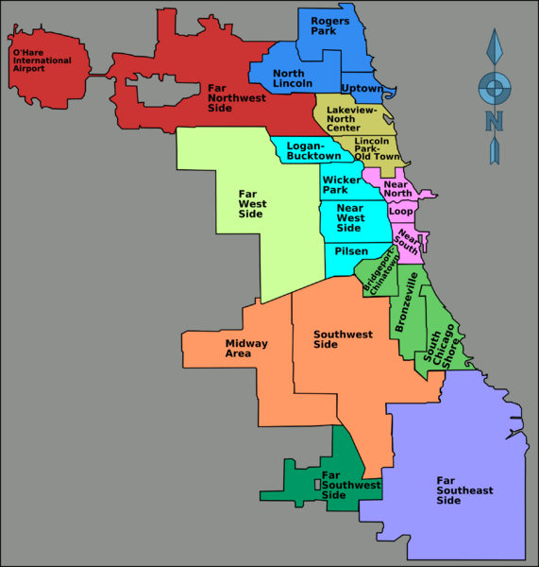

*Gentrification - The restoration and upgrading of deteriorated urban property by middle-class or affluent people, often resulting in displacement of lower-income people.

